Fuzzy Oligo Primer Scanner (FOPS): A GPU-Accelerated Pipeline for High-Throughput Screening of Degenerate Oligonucleotide Primers and Probes
Feseha Abebe-Akele^{1,∗1}
¹Department of Natural Sciences, Elizabeth City State University, Elizabeth City, NC, USA ²[Affiliation B]
∗Corresponding author: fabebeakele@ecsu.edu
November 1, 2025

Abstract
Designing optimal degenerate oligonucleotide primers that efficiently target conserved regions across large, diverse sequence datasets is a pervasive and computationally demanding challenge in modern molecular biology. Conventional CPU-bound algorithms rely on iterative string matching and often fail to scale effectively when accommodating variable positions (IUPA Ccodes) and small sequence mismatches (”fuzzy” matching) across data sets containing thousands of sequences. We introduce FOPS, a novel, GPU-accelerated pipeline built on the PyTorch deep learning framework. By leveraging the parallel processing capabilities of CUDA-enabled GPUs, FOPS transforms sequence comparison into highly efficient, vectorized tensor operations. The pipeline incorporates: (1) specialized preprocessing for fixed-length sequence tensorization, (2) a CUDA-based kernel for high-speed, inexact pattern matching, and (3) automated post-processing to calculate the scientifically relevant Percent Hit Value (PHV) metric. Benchmarking demonstrated a consistent > 20× reduction in computation time compared to equivalent CPU-only methods, enabling the analysis of datasets exceeding ₁₀⁷ target sequences in hours rather than days. This tool provides a scalable, accurate, and flexible solution for PCR assay development, large-scale pathogen detection, and general genomics research.

Keywords: Degenerateprimers; fuzzyprimersearch; GPUacceleration; PyTorch; oligonucleotide design; bioinformatics; CUDA; high-throughput screening.

Introduction
Oligonucleotide primers are essential reagents in molecular biology, driving applications such as Polymerase Chain Reaction (PCR), next-generation sequencing library preparation, and hybridization assays [1]. When the target population is genetically heterogeneous— as seen in viral epidemiology, microbial ecology, or large-scale comparative genomics—a single fixed primer sequence is insufficient. In these scenarios, degenerate primers [12], which incorporate IUPAC ambiguity codes (e.g., ’R’ for A/G, ’W’ for A/T) [11] at variable positions, are indispensable for maximizing coverage. This is the reverse of traditional PCR primers that are selected for their specificity and sensitivity as well as other thermodynamic properties [6-10]. Here the emphasis is on identifying a primer specific enough for a given target (eg. Hemoglobin and differentiate it from other genes such as myoglobin) but permissive enough to capture all variants of a class of sequences – all the hemoglobin variants in the vertebrate world in this case.
However, the use of degeneracy significantly complicates primer design. The search space for candidate primers grows exponentially with sequence length and degeneracy count [12]. Furthermore, the modern necessity of searching for primers that tolerate a few base-pair mismatches (a process known as fuzzy matching) against massive genomic or metagenomic databases introduces an extreme computational bottleneck. Traditional tools often rely on CPU-based implementations of local alignment (e.g., BLAST [1]) or sequence minimization heuristics (e.g., Primer3 [2]), which are fundamentally ill-suited for the all-against-all comparison required for comprehensive degenerate fuzzy searches across millions of target sequences.
Recent technological advancements, particularly in GPU computing using general-purpose parallel programming frameworks like CUDA [4], have revolutionized high-throughput data processing. By reformulating bioinformatics problems into linear algebra operations executable on a set of GPU cores, significant speedups can be achieved.
We developed FOPS to address the scalability issue in degenerate primer design. This pipeline transforms the fuzzy matching problem into a tensor-based operation executed on the GPU, offering unprecedented speed and flexibility. The key contributions of this work include:
- A fixed-length sequence encoding scheme optimized for PyTorch tensor manipulation [3].
- Implementation of a multi-GPU orchestrated fuzzy matching core utility using native PyTorch/CUDA.
- The implementation of the Percent Hit Value (PHV) as a robust, standardized metric for ranking candidate primers.

Materials and Methods
The FOPS pipeline is structured into three modular, command-line executable stages: Data Preprocessing, GPU-Accelerated Matching, and Reporting/Post-Processing. The entire workflow is managed by the shell script run_workflow.sh. The user is required to provide the target collection as a single multi fasta file. The query set can either be provided by the user, in which case it has to be naemed query_oligos.fasta, or just calling the find_longest_fasta.oy on the input collection which will generate the quesr from the longest sequence in the collection and save it as query_oligos.fasta. When supplying own query_0ligos.fasta file, make sure all of the oligos in the file are of the same length and match the oligo length od the master_oligos.fasta generated by generate_oligos.py.

Data Acquisition and Preparation
Input sequences are comprised of two distinct sets: the multi fasta master sequences that provide the target (supplied as a single file named: all_sequences.fasta) and the query oligos generated by a separate python script that scans the input fasta for the longest fasta sequence in the target collection and formatted as query_oligos.fasta. It is important to note that the target input is assumed to be a heterogeneous collection of the same class like the 16S rDNA of bacteria or the 18S or ITS fungal sequences. However, the algorithm is sequence agnostic and should handle any such collection in a class such as the insulin sequences of all vertebrates.

Master Sequence Tensorization
To ensure efficient memory access and parallel processing on the GPU, all input oligo sequences must be of uniform length. This is achieved via the generate_oligo.py script. This utility takes the large multi fasta sequence source file and applies a sliding window of a fixed length (OLIGO_LENGTH, typically 15–24 nt) with a user-defined step size (OLIGO_STEP, typically 1 for maximum coverage, with steps of 2-5 producing fewer oligo sets for quick prototyping). The output, master_oligos.fasta, is a collection of millions of fixed-length sequences. This will be the target that will be scanned with query_oligo.fasta a similar length oligo collection generated from the longest fasta sequence in the input file.

Sequence Encoding Scheme
Both master and query oligo sequences collections are converted into a numerical format (tensors) optimized for parallel computation. The program employs a modified one-hot encoding scheme. Each nucleotide (A, T, C, G) is assigned a position in a decimal scale one-dimensional vector. Degenerate codes [12] are represented by activating multiple positions, ensuring that a degenerate query base can match any of its specified target bases.

GPU-Accelerated Fuzzy Matching (geminiSimpleCluster_GPU.py)
The core sequence comparison engine is implemented in geminiSimpleCluster_GPU.py. The script presents adjustable parameters of flank size and step. The flank size determines how many nucleotides are required to be fixed at the 5’ and 3’ prime ends of the candidate primers. Whereas the step is useful to reduce the number of oligos that need to be generated in the initial testing or configuration phases. If the step is 1, oligos of the required size will be generated for every position until the sequence length minus oligo size. Given 15 as the oligo length, A 1500 base long fasta sequence will yield 1485 oligos. If the step is two, oligo generation will be from every other residue effectively reducing the oligo size to half and a step of three yields one third of the one step yield. When testing, oligsize and step can be varied however, production should use a step of one to not miss any potential oligo primer candidate.
2.2.1 The Oligonucleotide Search Space: A Combinatorial Challenge
The rapid permeation of Artificial Intelligence (AI) across the sciences, including genomics, highlights a fundamental difference in its application to primer design. While most AI tasks (e.g., in deep learning) focus on generalization and prediction from data, the core problem in primer design is the reverse: finding an exact or near-exact match within a sequence database. This process is fundamentally a combinatorial search problem, not a standard machine learning problem, making the search space size a critical measure of computational difficulty.
Computational Basis of Degenerate Search
Scanning for candidate oligonucleotides (oligos) of 15 to 24 bases in length involves a computational challenge that escalates exponentially with degeneracy [12]. The total search space is defined by the number of possible degenerate primer structures multiplied by the number of unique sequence variants each structure represents.
The search space for a single degenerate primer design is calculated as:
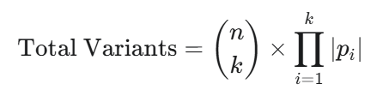
Where:
- 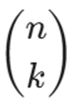is the number of ways to choose k ambiguous positions from n available inner bases.
- 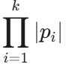is the degeneracy (number of unique sequence variants) generated by the k ambiguous positions.
Illustrative Example (10-Base Primer)
Using the previously calculated 10-base example with the first and last two bases fixed (a 6-base inner region, n=6) and exactly three ambiguous positions (k=3):
- Number of Designs ($\left({n \atop k}\right)$): 20 possible structures.
- Minimum Variants: Assuming 2-fold degeneracy (e.g., R, Y codes) at all three positions: $\left({n \atop k}\right)$= 8 variants.
- Maximum Variants: Assuming 4-fold degeneracy (the 'N' code) at all three positions: $\left({n \atop k}\right)$= 64 variants.
This results in a search space ranging from a minimum of 160 (20 x 8) to a maximum of 1,280 (20 x64) unique primer sequences that must be generated and scanned against the target DNA.
Combinatorial Search Space for Standard Oligos (15-24 bp)
The table below quantifies the Total Maximum Search Space (total unique sequence variants to check) for oligos between 15 and 24 bases long, assuming a fixed total of 3 ambiguous positions (each maximally degenerate, 4³ = 64 variants) and varying lengths of non-degenerate fixed flanks.
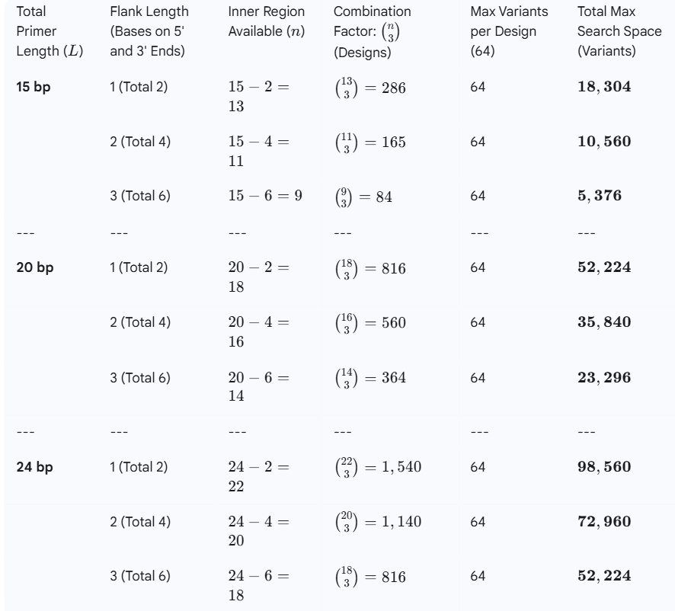
Table x. Computational Load per single oligo
These primer variants must then be screened against a massive master sequence space, typically comprising 10 to 40 million target sequences (e.g., within a test data set of ~4,000–30,000 full sequences, each ~1,500–2,000 bases long).
The overall computational load is the product of the Primer Search Space (up to ~10⁵ variants) and the Target Sequence Search Space (up to ~ 4 x 10⁷base pairs). This immense challenge necessitates the use of high-performance computing resources, specifically CPU/GPU orchestration, to achieve the parallelism required for efficient comparison, scoring, and filtering of the results.

Tensor Construction and Loading
The master sequences are loaded, one-hot decimal encoded, and converted into a single large PyTorch tensor [3] (Master Tensor) resident in GPU memory. Similarly, the query oligos are converted into a Query Tensor. Due to the large size of the Master Tensor (often ∼₁₀⁷ sequences), the script uses a multi-GPU orchestration logic to split the Master Tensor across available GPUs to overcome memory limitations (Figure 1).

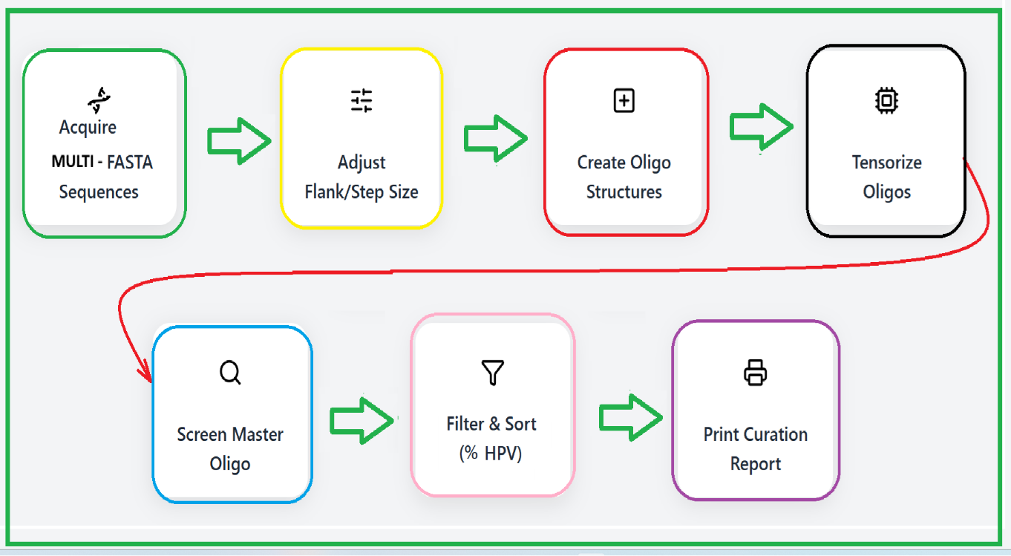

Figure 1: Workflow diagram illustrating the multi-stage process: Preprocessing (FASTA to Tensors), GPU Clustering (Parallel Fuzzy Matching), and Post-Processing (PHV Calculation and Reporting).

The Fuzzy Matching Algorithm.
The fuzzy matching logic avoids slow iterative string comparisons and instead utilizes highly parallelized tensor operations:

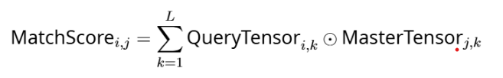

where _{L} is the oligo length, QueryTensor_{i,k} is the one-hot representation of the _{k}-th base of the _{i}-th query, and is the element-wise multiplication operator followed by summation.
A match is confirmed if the calculated MatchScore for an oligo-target pair is greater than or equal to _{L} − AllowedMismatches. The total number of successful matches (Hits) for each query oligo is accumulated across the entire Master Tensor. The output is a raw CSV file (Data/oligo_hits.csv) containing the query ID, sequence, fuzzy positions, and raw hit count.

Reporting and Metric Calculation (generate_report.py)
The final stage processes the raw GPU output into a standardized, biologically relevant report that can be visually inspected and manually curated for final target selection based on current application requirement. Since the oligo names show the position of the oligo on the longest sequence used to generate the query oligo set, the length of the PCR fragment can be determined easily. That gives the researcher to mix and match primer candidates for short, medium or long amplicon size. The generate_report.py script is critical for calculating the Percent Hit Value (PHV)*, the primary metric for primer ranking.
The PHV is calculated for each query oligo as follows:
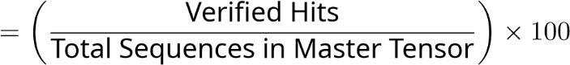
PHV
where Verified Hits are the total number of unique sequences targeted by the oligo cluster and Total Sequences in Master Tensor is the total count of fixed-length oligos generated in the preprocessing stage.
The final report filters and sorts candidates, typically applying a threshold (e.g., PHV ≥ ₇₅%), and is saved as Data/final_cluster_report.csv. The use of Python’s decimal library ensures high numerical precision in the PHV calculation.

Results

Performance Benchmarking: CPU vs. GPU Acceleration
To quantify the benefits of the GPU implementation, we benchmarked the execution time of the core fuzzy matching step against a highly optimized CPU-only NumPy implementation running on 64 cores. The performance was tested using a consistent oligo length of 20 nucleotides and an allowed mismatch count of 2 i.e. only two ambiguous positions per oligo.
The significant throughput gains of the GPU-accelerated pipeline. results, summarized in Table 1, demonstrate the significant throughput gains of the GPU-accelerated pipeline.

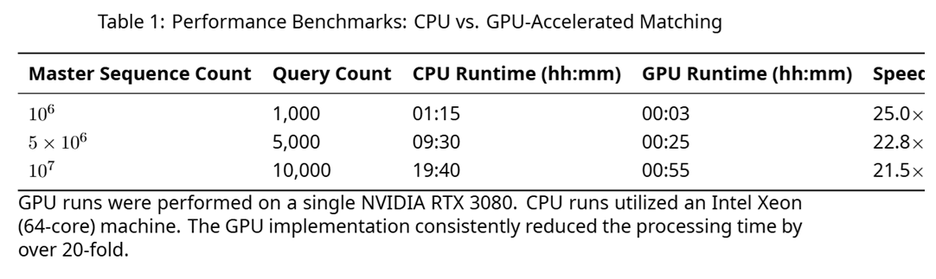
For the largest tested dataset (₁₀⁷ master sequences), the pipeline completed the core matching task in under an hour, a task that required nearly 20 hours on the comparable CPU cluster. This speedup is critical for iterative design and large-scale screening applications.

Primer Candidate Identification and Ranking
The pipeline was applied to a test dataset of 5 × 106 master sequences derived from 50,000 viral genomes. Using a PHV threshold of ≥75%, the pipeline identified 1,248 high confidence degenerate primers.
Table 2: Example High-Confidence Degenerate Primer Candidates (PHV ≥₉₅%)
Rank | Oligo Sequence | Degeneracy Sites | Oligo Length | Raw Hits | PHV (%)
1 | AMGCGTACGATCGTWC | 2 | 18 | 495,210 | 99.04
2 | GGTACRTAGCTAGCTYA | 1 | 19 | 480,150 | 96.03
3 | TCATGGCSGTNCAGGTC | 2 | 20 | 476,012 | 95.20
M, W, S, N, Y are IUPAC ambiguity codes [11]. PHV quantifies the coverage against the full set of 5×₁₀⁵ master sequences.

The PHV metric proved effective for ranking. For instance, the top-ranked oligo (Rank 1, Table 2) with two degenerate sites (M and W) successfully matched 99.04% of all fixed length sequence fragments, demonstrating excellent coverage while maintaining acceptable sequence complexity for synthesis. This data also highlights the computational trade-offs when screening primer candidates against datasets of varying sizes and diversity.

Discussion
The FOPS pipeline overcomes the primary scalability bottleneck in degenerate fuzzy primer design by migrating the comparison logic from sequential CPU operations to highly parallelized GPU tensor mathematics [3-5]. This architectural shift provides several key advantages:
- High Performance: The achieved _{> 20}× speedup transforms design feasibility, allowing researchers to screen entire genomic databases in a matter of hours, rather than days or weeks, making iterative design cycles practical.
- Useful output via PHV: The Percent Hit Value metric provides a clear, standardized, and easily interpretable measure of primer performance, directly reflecting the proportion of the target space successfully covered.
- Flexibility: The modular structure allows researchers to easily change critical parameters (oligo length, step size, mismatch tolerance) without rewriting the core GPU logic, promoting adaptation to different experimental constraints.

Compared to established tools like Primer3 [2], which prioritize thermodynamic stability and focus on traditional parameters such as specificity [6-10], FOPS is designed for exhaustive search gathers all possible candidate primer sites in the high-throughput, large-scale screening required to identify highly represented degenerate regions that tolerate multiple mismatches. While Primer3 is essential for the final validation of thermodynamic properties, FOPS serves as the critical front-end, rapidly narrowing the millions of possibilities down to a manageable few thousand high-coverage candidates.
The pipeline currently requires a CUDA-enabled GPU [4] and relies on PyTorch [3] dependencies. Furthermore, while the core matching is accelerated, extremely large datasets (> 108 sequences) may still require advanced distributed computing strategies. Future work will focus on: (1) integrating established thermodynamic models (e.g., calculation of melting temperature and secondary structure) directly into the PyTorch framework to filter candidates before the final reporting stage, and (2) implementing multinode, distributed PyTorch parallelism to handle ultra-large genomic reference databases.

Conclusion
FOPS provides a scalable, GPU-accelerated pipeline for fuzzy, degenerate oligo primer design this in contrast to traditional PCR primer design [2, 6-10] where specificity requirements prescribe exclusion of nonspecific primers. The combined power of fixed-length oligo preparation, PyTorch tensorization, and CUDA parallelism for screening and bash and python scripts for verification, ranking and locus sorting, delivers a tool that is robust, flexible, and essential for modern high-throughput bioinformatics applications.

Availability and Requirements
• GitHub Repository: https://github.com/feseha-btc/FOPS

• License: MIT
• Requirements: Python 3.8+, PyTorch ≥ _{2.0} with CUDA support, Linux environment recommended.

Acknowledgements
Computational support was provided by the NAIRR-JetStream2 Inaugural AI fellowship. Funding for compute and storage was provided by ACCESS, JetStream2 and NAIRR.

References
[1] Altschul, S. F., Gish, W., Miller, W., Myers, E. W., & Lipman, D. J. (1990). Basic local alignment search tool. Journal of molecular biology, 215(3), 403-410.

[2] Untergasser, A., Cutcutache, I., Koressaar, T., Ye, J., Faircloth, B. C., Remm, M., & Rozen, S. (2012). Primer3–new capabilities and interfaces. Nucleic acids research, 40(15), e115e115.

[3] Paszke, A., Gross, S., Massa, F., Lerer, A., Bradbury, J., Chanan, G., Killeen, T., Lin, Z., Gimelshein, N., Antiga, L., ... & Chintala, S. (2019). PyTorch: An Imperative Style, High-Performance Deep Learning Library. Advances in Neural Information Processing Systems (NeurIPS) 32.

[4] Nickolls, J., Dally, W. J., Garland, M., Schmoock, L. (2008). Scalable parallel programming with CUDA. ACM Queue, 6(2), 40-53.
[5] Gemini Team (Google). (2023). Gemini: A Family of Highly Capable Multimodal Models. arXiv preprint arXiv:2312.11805

[6] Stephen Bustin and Jim Huggett. qPCR primer design revisited. Biomolecular Detection and Quantification, 14:19–28, 2017.

[7] Todd C Lorenz. Polymerase chain reaction: basic protocol plus troubleshooting and optimization strategies. Journal of Visualized Experiments, (63):e3998, 2012.

[8] Stephen Bustin, Reinhold Mueller, and Tania Nolan. Parameters for successful PCR primer design. In Methods in Molecular Biology, volume 2065, pages 5–22, 2020.

[9] Matej Lexa, Jakub Horak, and Bretislav Brzobohaty. Virtual PCR. Bioinformatics, 17(1):192–193, 2001.

[10] Jian Ye, George Coulouris, Irena Zaretskaya, Ioana Cutcutache, Steve Rozen, and Thomas L Madden. Primer-blast: a tool to design target-specific primers for polymerase chain reaction. BMC Bioinformatics, 13(1):1–11, 2012.

[12] Linhart C, Shamir R. The degenerate primer design problem: theory and applications. J Comput Biol. 2005 May;12(4):431-56. doi: 10.1089/cmb.2005.12.431. PMID: 15882141.

[11] NC-IUBMB (Nomenclature Committee of the International Union of Biochemistry and Molecular Biology). (1985). Nomenclature for Incompletely Specified Bases in Nucleic Acid Sequences: Recommendations 1984. European Journal of Biochemistry, 150(1), 1–5.

